Project Assessment Documentation
Rental House Finding System
Hệ thống tìm nhà cho thuê

Supervisor: Mr. Phan Truong Lam
Students: NamNV01595
HungCQ01766
BichTT01501
VietVH01388
ChungNT01726

- Product overview.
The rental house finding system is a website for users to post a flat information such as price, area, location, images and the contact details of the owner. Users will be able to create and manage their accounts, as well as manage their own home information. Besides, user can also search and compare flat to find which is suitable for their needs. It provides useful function for user like saving favorite flat, view history, comment and so on. The website will focus on people who want to find a house for lease. Specific functions will be listed in details in the Functional Requirement Section.

- Functional Requirement.

Code | Description
For registered user
F01 | Login/logout
F02 | Edit user profile
F03 | Post, edit house for lease
F04 | Post, edit house rental requirements
F05 | Search (normal, advanced)
F06 | Compare two items
F07 | View item details
F08 | Manage favorite
Guest (unregistered user)
F09 | Register account
F10 | Search (normal, advanced)
F11 | Compare two items
Administrator
F12 | Categories management
F13 | Location management (city, province->district)
F14 | Manage posts
F15 | Manage moderators accounts
F16 | Manage payments (SMS)
F17 | Bad post reports (filter invalid contents)

- LITERATURE REVIEW OF EXISTING SYSTEMS
Currently, there are some popular systems with quite similar services in comparison to our system, both in Vietnam and worldwide such as:
- http://www.xomtrosv.com
- http://www.nhatroviet.com
- https://www.padmapper.com

XomtroSV.com: In overview, this website has supported users quite well with many general features of a standard advertisement website; however:
    - Website does not have comparing between similar topics.
    - It does not have view history and save favorites function.
    - It supports Google map but with limitation function implemented on this.



nhatroViet.com:
    - Each post has enough information: address, room type, date, rent, electric and water fees, contacts, etc.
    - Suggestion shows rooms on the same district.
    - Provide more related information that user may need:
      - News related to room seeking, giving user more information.
      - Can search for buses by number or by route.
    - No bookmark and rating
    - Google Map implementation has bug
    - Suggestion doesn’t show rooms on the same district, which helps users compare among candidate selections.
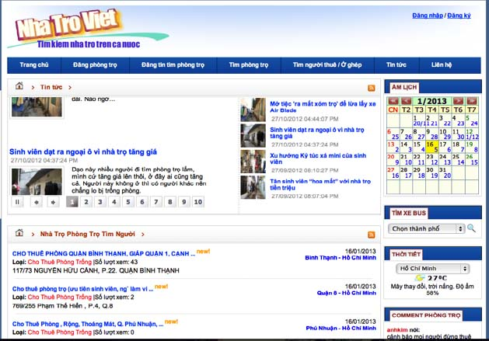

Padmapper.com:
    - It has visual interaction:
      - Support of nearly full screen map.
      - Have markers on the map, which helps users identify the location better.
      - It has visual scrolls for users to set range of their search.
    - Favorite list for users to refer later.
    - No comparison function between 2 or more positions.
    - No suggestion for other places near selected positions such as universities, markets, and hospitals…
